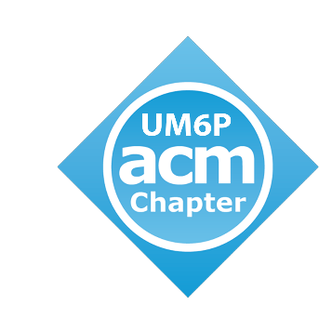 

**ACM CHAPTER ACTION PLAN**

**About the ACM Chapter at UM6P**

The ACM Chapter at UM6P is a dynamic and student-led organization founded by students from the College of Computing. Our chapter is committed to fostering a vibrant and inclusive community of computer science enthusiasts, researchers, and learners within the university. We aim to provide valuable opportunities for students to explore the world of computing, engage in collaborative projects, and connect with industry professionals.

**How ACM Chapter at UM6P Assures Diversity**

In alignment with our sponsor's commitment to diversity among university departments, the ACM Chapter at UM6P places a strong emphasis on promoting diversity and inclusivity in the field of computer science and technology. Here's how we assure diversity within our chapter and contribute to the university's broader goals:

**1. Diverse Membership:**

Our ACM Chapter actively recruits members from various backgrounds, cultures, and academic disciplines within UM6P. We believe that diversity in our membership enriches our discussions, perspectives, and solutions to complex computing challenges.

**2. Inclusive Events and Activities:**

We organize a wide range of events, workshops, and seminars that cater to the interests and abilities of all students. These events are designed to be inclusive and welcoming to individuals with varying levels of experience in computing.

**3. Mentorship and Support:**

We offer mentorship programs where experienced members provide guidance and support to students from underrepresented backgrounds in computing. This initiative helps bridge the diversity gap in technology-related fields.

**4. Collaboration with Diversity Initiatives :**

We actively collaborate with UM6P's diversity initiatives and related student organizations to create synergies in promoting diversity within the College of Computing and across the university.

**5. Guest Speakers and Panel Discussions:**

We invite guest speakers and organize panel discussions featuring professionals from diverse backgrounds in technology. These events provide valuable insights into the importance of diversity in the tech industry.

**6. Events planning:**

|  |  |  |  |
| --- | --- | --- | --- |
| **EVENTS** | **DESCRIPTION** | **SCALE** | **TIMELINE** |
| Integration Day Event | Organization of an integration day event with entertaining activities such as: | College of Computing | October |
| Seminars | In partnership with College of Computing, the chapter will co-organize many Tech seminars inviting top notch researchers and professionals. | UM6P | Monthly |
| Competitive Programming Bootcamp | In partnership with College of Computing, the chapter is aiming to co-organize Competitive programming bootcamps where certificates will be presented | College of Computing | September 2023  November 2024 |
| Competitive Programming Contest | Organize a local CP contest, open to all students of UM6P, where they can compete in solving problems showcasing their algorithmic thinking and programming skills. | UM6P | November 2023 / December 2023 |
| Computer Science Courses | Offer a variety of courses in data science, machine learning, and basic programming knowledge, open to all UM6P students. | UM6P | Monthly |

By supporting the ACM Student Chapter at UM6P, you are investing in the future of computing and technology. Our mission is to inspire innovation, advance knowledge, and contribute positively to the world through technology. Together, we shape the future of computing.